Chapter1 revision
Name: ____________________ Class: ____________________ Due date: 9.23
1. - (0620- W 2013- Paper 1 (Core)/1- Q1) - STATES OF MATTER
An attempt was made to compress a gas and a solid using the apparatus shown.
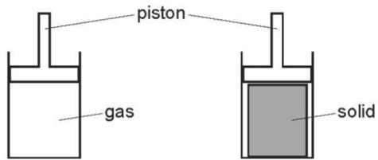
Which substance would be compressed and what is the reason for this? （ ）
 | substance | reason
A | gas | the gas particles are close together
B | gas | the gas particles are far apart
C | solid | the solid particles are close together
D | solid | the solid particles are far apart

2. When a substance is heated from a solid to a liquid and then to a gas, the energy is mainly used to （ ）
A. Increase the kinetic energy of the particles B. Break the attraction forces
C. Change the color of the substance D. Increase the mass of the substance
${CH}_{4}$$C_{2}H_{4}$3.The rate of diffusion of two gases, methane, , and ethene, , is measured using the apparatus shown.
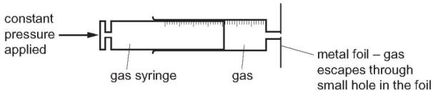
Which gas diffuses faster and why? （ ）
 | gas that diffuses faster | reason
A | ethene | Ethene molecules are heavier and so move faster.
B | ethene | Ethene molecules have a double bond which makes them more reactive.
C | methane | Methane molecules are lighter and so move faster.
D | methane | Methane molecules are smaller so they can get out of the small hole more easily.
4.The diagram shows some changes of state.
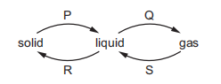
Which words describe the changes of state, P, Q, R and S? （ ）
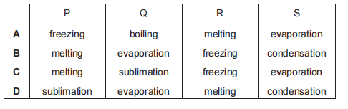

5. The melting points and boiling points of three elements, at 1 atm pressure, are shown.
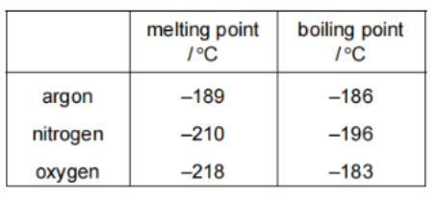
Separate samples of argon, nitrogen and oxygen are stored at -211℃ and at 1 atm pressure
How many samples are liquids? （ ）
A.0 B.1 C.2 D.3

6. Describe what happens to the particles of a substance during the process of melting

7. - (0620- W 2016- Paper 4 (Extended)/2- Q1) - STATES OF MATTER
Particles behave differently when in different physical states.
a. Solids have a fixed volume and a definite shape.
Liquids have a fixed volume and take the shape of the container.
Describe the volume and shape of gas.

8. - (0620- S 2019- Paper 4 (Extended)/1- Q2) - STATES OF MATTER
Z is a covalent substance. In an experiment, a sample of pure solid Z was continually heated for 11 minutes.
The graph shows how the temperature of the sample of pure Z changed during the first 9 minutes.
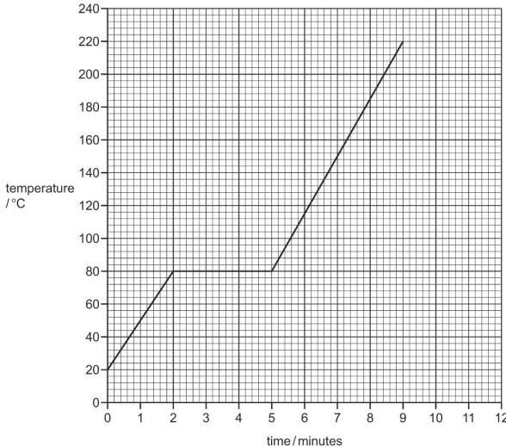
a.What is the melting point of pure Z?
..................................................................................................................................[1]
b.The sample of pure Z began to boil at 9 minutes. It was boiled for 2 minutes.
Use this information to sketch on the grid how the temperature of the sample of pure Z changed between 9 minutes and 11 minutes. [1]
c.The sample of pure Z was continually heated between 2 minutes and 5 minutes.
Explain, in terms of attractive forces, why there was no increase in the temperature of the sample of pure Z between 2 minutes and 5 minutes.
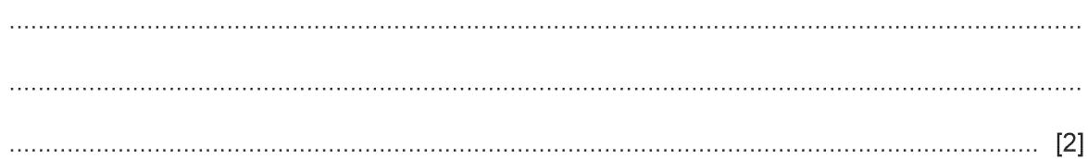
d.Describe how the motion of particles of pure Z changed from 0 minutes to 2 minutes.
..................................................................................................................................
..................................................................................................................................[2]
e.The experiment was repeated using a solid sample of impure Z.
Suggest the differences, if any, in the melting point and boiling point of the sample of impure Z compared to the sample of pure Z.
melting point..........................................................................................................
boiling point...................................................................................................... [2]

9 .Different gases diffuse at different speeds.
What is meant by the term diffusion?
.......................................................................................................................................
.......................................................................................................................................
10. Gases diffuse, which means that they move to occupy the total available volume.
Explain, using kinetic particle theory, why gases diffuse.
.......................................................................................................................................
.......................................................................................................................................
ii.When the colourless gases hydrogen bromide and ethylamine come into contact, a white solid is formed.
The following apparatus can be used to compare the rates of diffusion of the two gases ethylamine and hydrogen bromide.
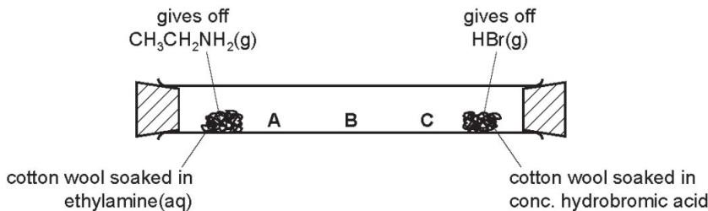
Predict at which position, A, B or C, the white solid will form. Explain your choice.
.......................................................................................................................................
.......................................................................................................................................

